READINESS ASSESSMENT FOR THE PREVENTION OF CHILD MALTREATMENT

RAP-CM

SHORT VERSION – Scoring system

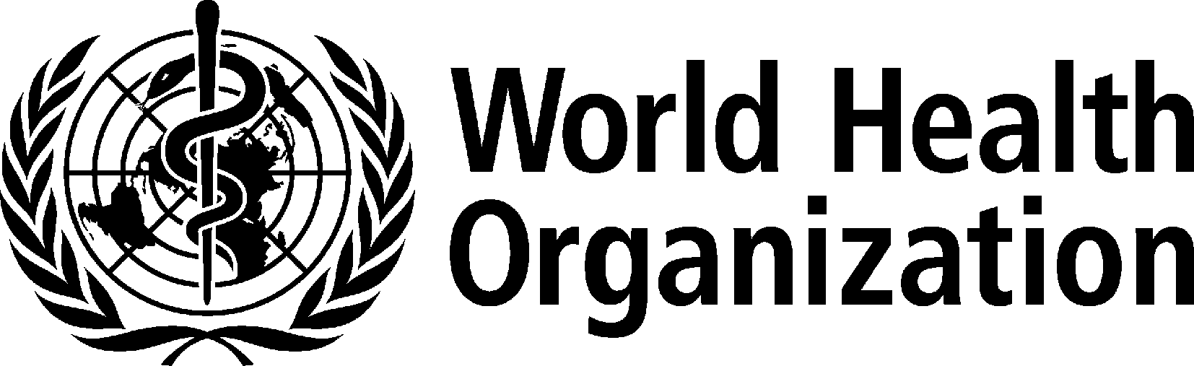

Table for total score and score on each dimension of RAP-CM-SV

After you have scored each of the individual questions, enter scores into this to calculate total scores for each dimension and the overall total score.

Dimension | Score out of 4 | Score out 10
Dimension 1: Attitudes towards child maltreatment prevention | /4 | /10
Dimension 2: Knowledge of child maltreatment prevention | /4 | /10
Dimension 3: Scientific data on child maltreatment prevention | /4 | /10
Dimension 4: Current programme implementation and evaluation | /4 | /10
Dimension 5: Legislation, mandates, and policies | /4 | /10
Dimension 6: Will to address the problem | /4 | /10
Dimension 7: Institutional links and resources | /4 | /10
Dimension 8: Material resources | /4 | /10
Dimension 9: Human and technical resources | /4 | /10
Dimension 10: Informal social resources (non-institutional) | /4 | /10
Total child maltreatment prevention readiness score | /40 | %

For each dimension, to get score out of 10: (Score out of 4) X 2.5
To get overall score in %: (total score out of 40) X 2.5

Dimension 1: Attitudes towards child maltreatment
1. | In Name of Country/Province/ Community, compared to other health and social problems, how much of a priority is child maltreatment prevention (i.e. taking measures to prevent child maltreatment before it occurs)? | High priority 2  Moderate priority 1  Low priority 0  Don't know 0 | /2
2. | Do you think that measures taken so far to prevent child maltreatment in Name of Country/Province/ Community have been adequate? | Adequate 2  Neither adequate nor inadequate 1  Inadequate 0 | /2
Dimension 2: Knowledge of child maltreatment prevention
3. | In your opinion, what are the main types of consequences of child maltreatment for the victim in Name of Country/Province/Community? Please list as many types as you can think of. | If 5+ different consequences mentioned 2  If 1-4 mentioned 1  If 0 mentioned 0  Don't know 0 | /2
4. | What do you think are the main types of risk factors for child maltreatment in Name of Country/Province/ Community? Please list as many types as you can think of. | If 5+ different risk factors mentioned 2  If 1-4 mentioned 1  If 0 mentioned 0  Don't know 0 | /2
Dimension 3: Scientific data on child maltreatment prevention
5. | As there data on the magnitude and distribution of child maltreatment in general in Name of Country/Province/ Community?  If so how good is the quality of these data? | Yes such data exist and their quality is good2  Yes such data exist, but their quality is low or fair or you do not know quality 1  No 0  Don't know 0 | /2
6. | As there data on the magnitude and distribution of child sexual abuse  available in Name of Country/ Province/Community?  If so how good is the quality of these data? | Yes such data exist and their quality is good2  Yes such data exist, but their quality is low or fair or you do not know quality 1  No 0  Don't know 0 | /2

Dimension 4: Current programme implementation
7. | Please list the names of child maltreatment programmes you are aware of that are currently being or have in the past been implemented in Name of Country/Province/ Community |  | If names of 5+ programmes listed 4  If names of 4 programmes listed 3  If names of 2-3 programmes listed 2  If names of 1 programmes listed 1  If no names of programmes listed 0  Don't know 0 | /4
Dimension 5: Legislation, mandates, and policies
8. | Are any governmental or non-governmental agencies officially mandated with child maltreatment prevention in Name of Country/Province/ Community? | Yes 2  No 1  Don't know 0 |  | /2
9. | Is there an official policy – or are there official policies - specifically addressing child maltreatment prevention in Name of Country/Province/ Community? If so, can you tell me about it/them? | Yes 2  No 1  Don't know 0 |  | /2
Dimension 6: Will to address the problem
10. | In Name of Country/Province/ Community, are there political leaders who express strong commitment to the issue of child maltreatment prevention and are taking effective measures to address the problem? | Yes 2  Not clear 1  No 0  Don't know 0 |  | /2
11. | How intensive have communication efforts been concerning child maltreatment prevention in Name of Country/Province/Community? | Intensive 2  Moderate 1  Weak 0  Don't know 0 |  | /2
Dimension 7: Institutional resources and links
12. | Can you list the names of any institutions currently involved in child maltreatment prevention? Please list as many as you can think of. |  | If names of 5+ institutions listed 2  If names of 1-4 institutions listed 1  If no names of institutions listed 0  Don't know 0 | /2
13. | Can you list the names of any partnerships, alliances, coalitions, or networks of institutions in Name of Country/Province/Community which are wholly or in a large part dedicated to child maltreatment prevention? Please list as many types as you can think of. |  | If names of 3+ partnerships/alliances/coalitions/ networks listed 2  If names of 1-2 partnerships/alliances/coalitions/ networks listed 1  If no names of partnerships/alliances/coalitions/ networks listed 0  Don't know 0 | /2
Dimension 8: Material resources
14. | Does the ministry (or department) of social welfare (or nearest equivalent in the country) have a dedicated budget for child maltreatment prevention? | Yes 2  No 1  Don't know 0 |  | /2
15. | Are there dedicated budgets in other parts of government (e.g. other ministries, departments, etc.) in Name of Country/ Province/Community for child maltreatment prevention besides the ministry (or department ) of social welfare? | Yes 2  No 1  Don't know 0 |  | /2
Dimension 9: Human and technical resources
16. | Overall in Name of Country/Province/ Community, do you think the number of professionals specializing in child maltreatment prevention is adequate for large-scale implementation of child maltreatment prevention programmes? | Adequate 2  Neither adequate nor inadequate 1  Inadequate 0  There are none 0  Don't know 0 |  |  | /2
17. | How widely available are undergraduate or postgraduate educational institutions which devote some of the curriculum to child maltreatment prevention? | Widely available 2  Some or a few 1  None 0  Don't know 0 |  |  | /2
Dimension 10: Informal social resources
18. | What level of citizens' participation is there typically in efforts to address various health and social problems in Name of Country/Province/ Community? | High 2  Moderate 1  Low 0  Don't know 0 |  |  | /2
19. | How good at getting things done through their joint efforts are the people living in Name of Country/Province/Community? | Good 2  Moderate 1  Poor 0  Don't know 0 |  |  | /2

